Assignment for **Oracle E- Business Suite Inventory**

Date:15th Nov-2024

[Provide screenshots of each step (which performed in a live environment).  
As evidence all the activity screens shot needs to be attached]

1. What is the Oracle Inventory module?

* A part of the Oracle E-Business-Suite, primarily used for managing inventory and items in a business.

2.With you User id switch to: **Vision Operation Inventory**. Responsibility.

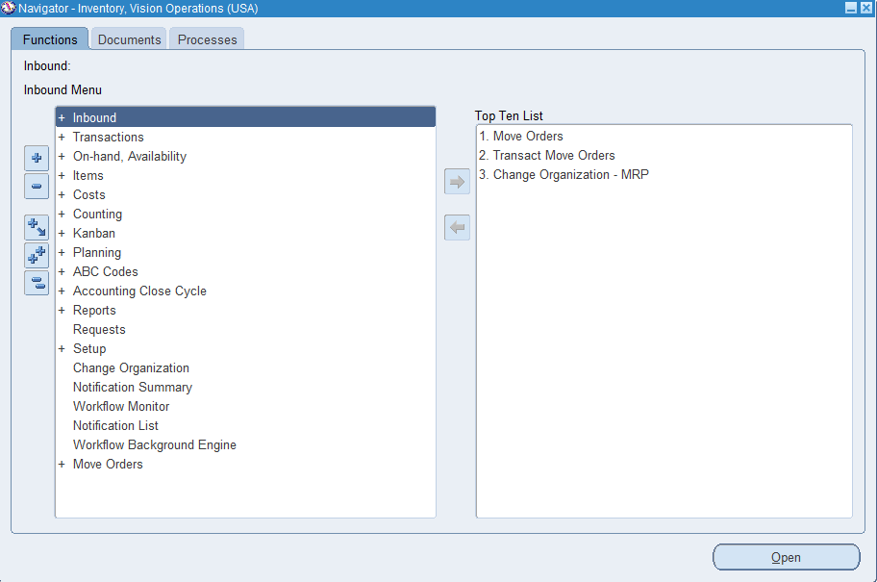

3.Choose **VI Inventory Org & Find the master Items.**

Organization:V1>Items>Master Items>Ctrl F11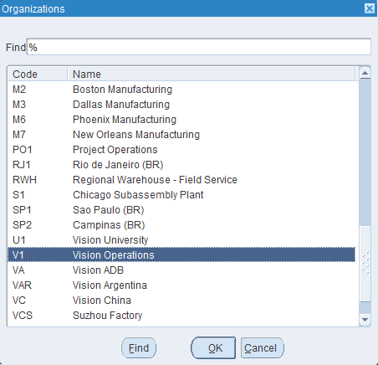

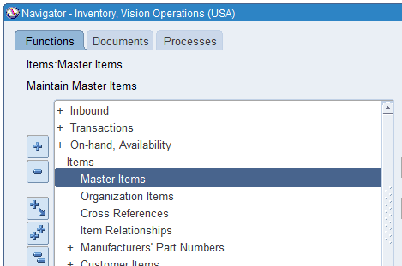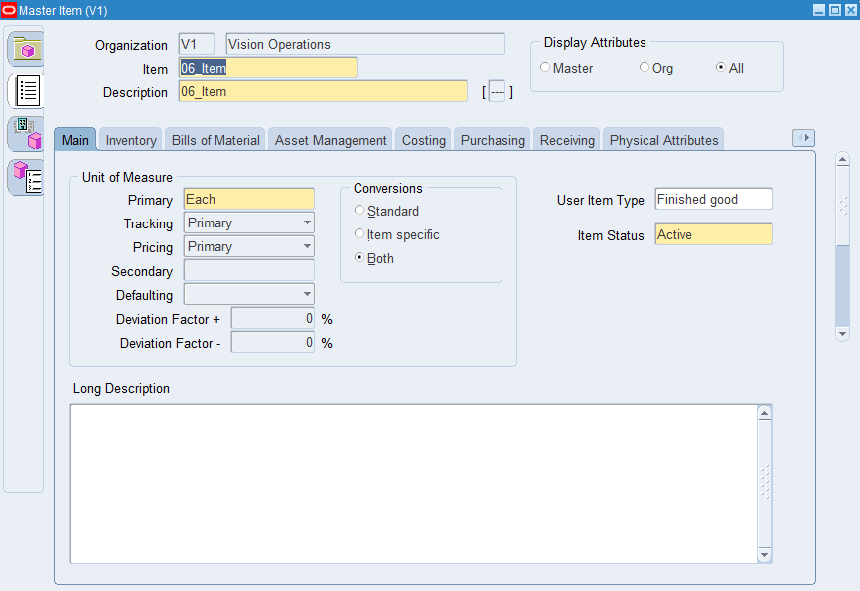

4.Take any Item & assign the same Item for all the **Inventory Org.**

* Find your item: Ctrl + Fn + F11> Organization Assignment> Assign all

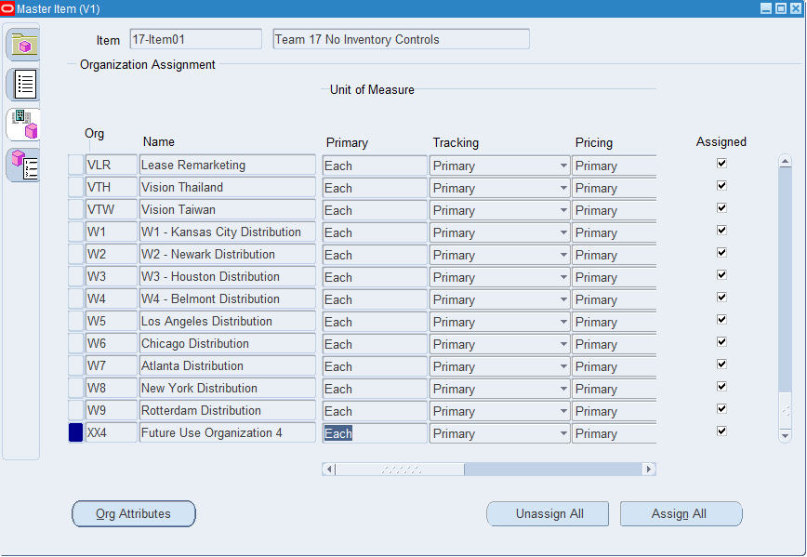

5. And Un assign the same Item for all the **Inventory Org.**

* Find your item: Ctrl + Fn + F11> Organization Assignment> unassign all

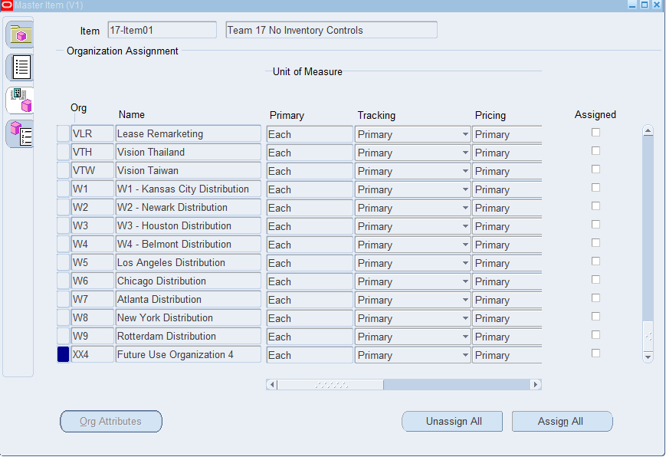

6**.** Any of the existing Item [VI Inventory org] Check the on-hand quantity

On-Hand, Availability>On-hand Quantity>Ctrl +F11> Find >Availability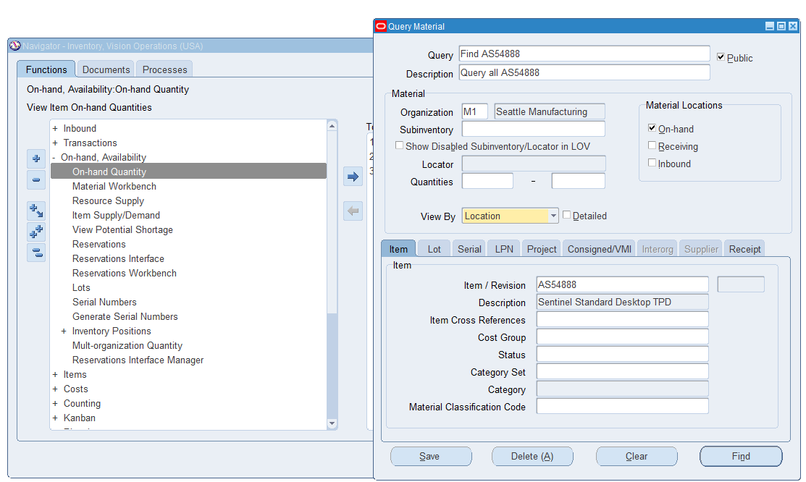

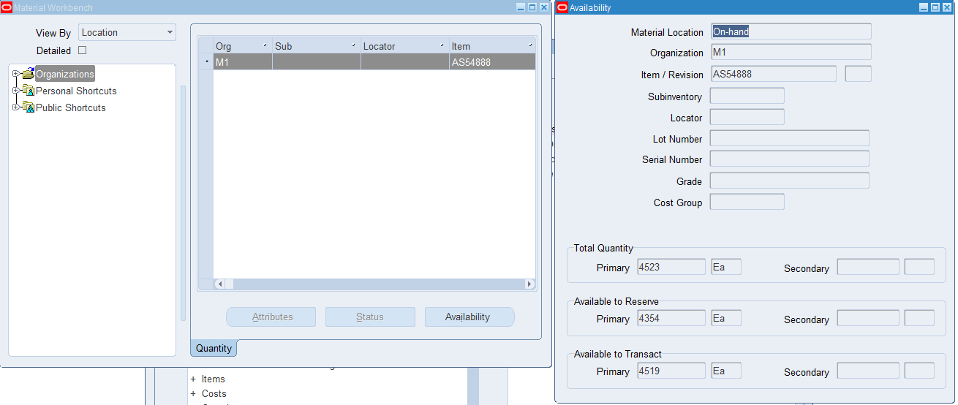

7. Unit of Measure (UOM)... with Navigation show where UOM has been defined.

Inventory>Setup>Units of Measure > Units of Measure > Pick your Organization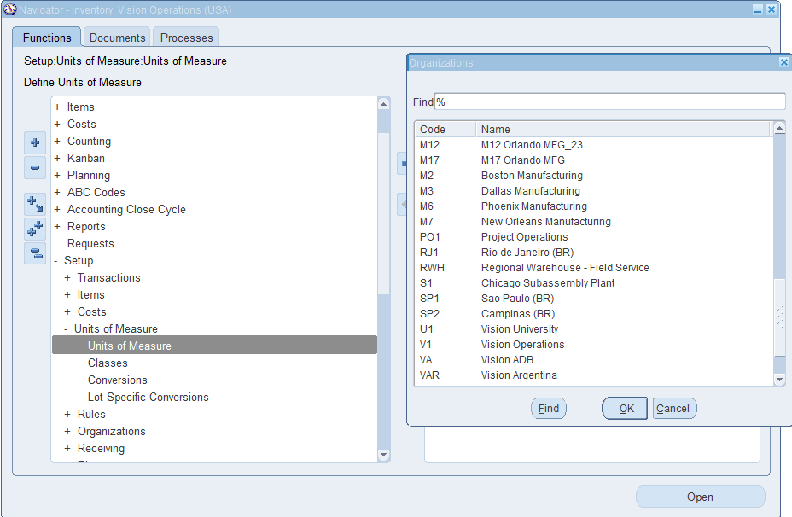

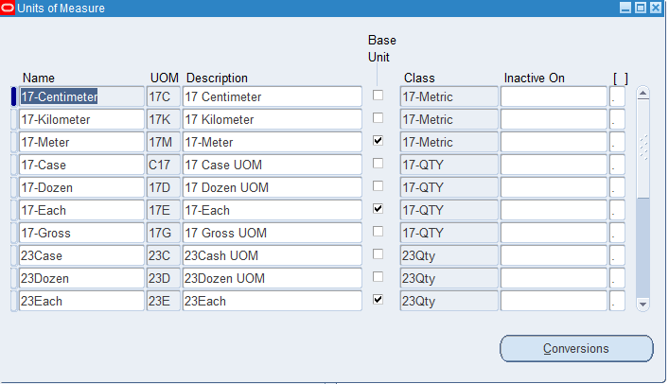

8. How do you create a new inventory item?

* items>master items>define your item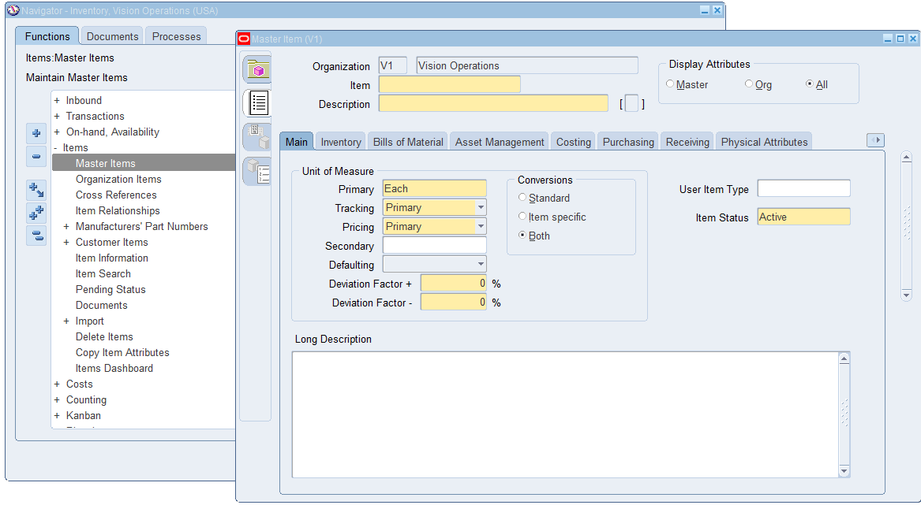

9. How to run Inventory Valuation Report?

Requests>Submit a new Request>Search>%val%

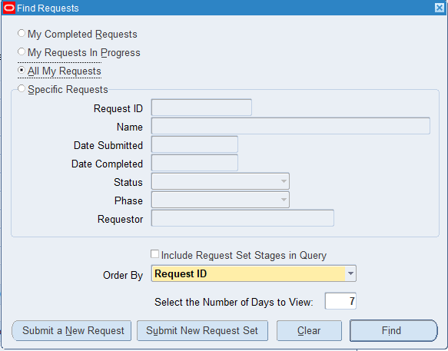

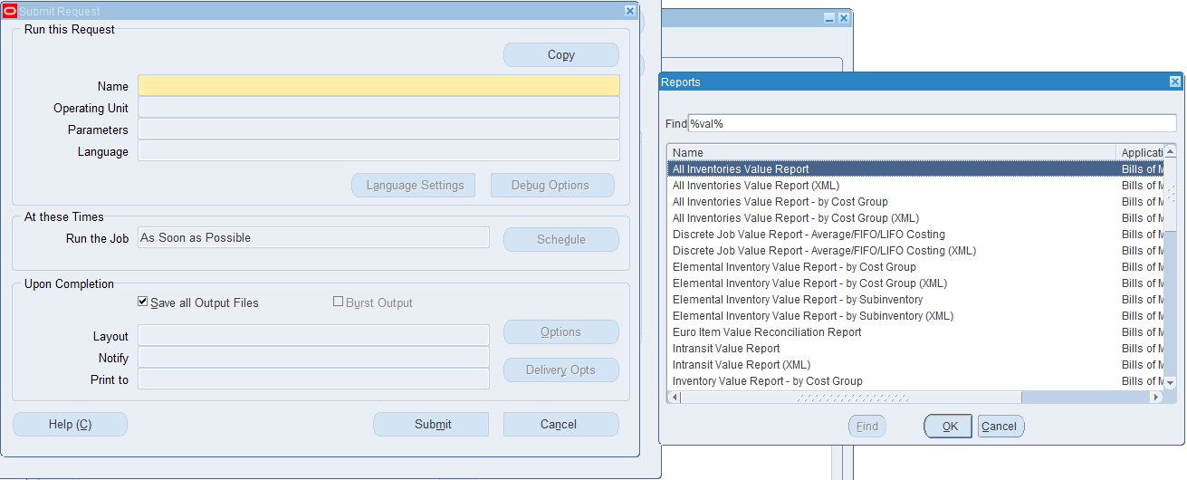

10.How to change Inventory Organization in the Current responsibility.

Inventory> Change organization>Select your organization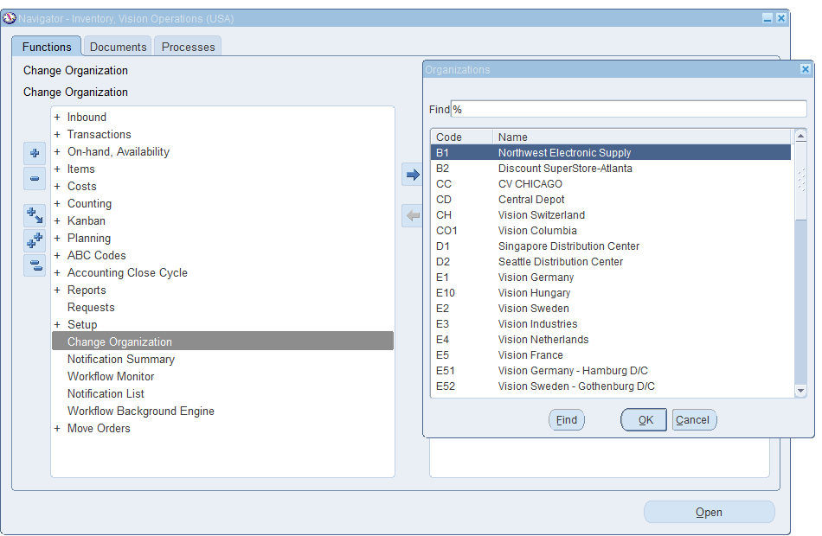

11. What is **Master Data** in Oracle Inventory?

Foundational Data required to define and manage inventory items, transactions, and processes. For example: Items, Units of Measure, Organizations, Subinventories, Categories, Costing information, Locations, Etc.

12.Show the existing ORG with navigation.

setup>organizations>organizations

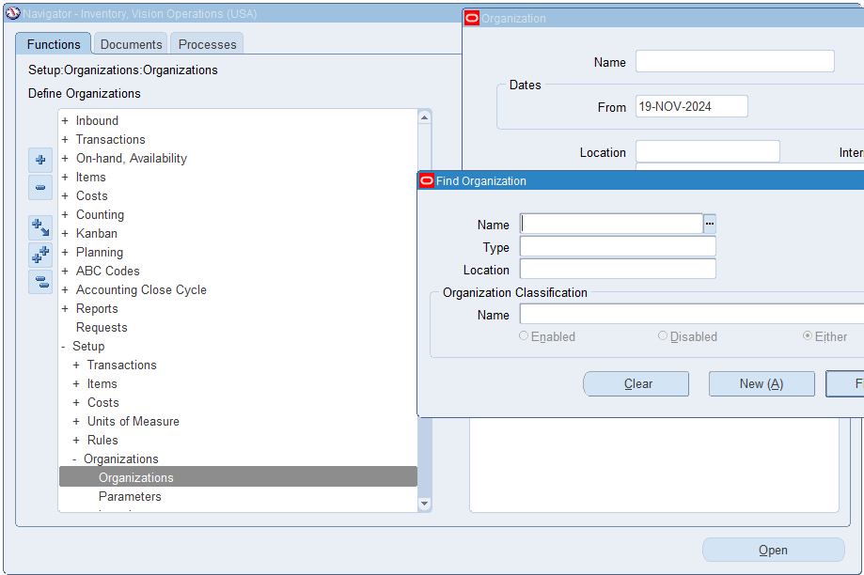

13: You can manage only finished goods in **Oracle Inventory**?

No oracle inventory is not limited to managing finished goods, it is a comprehensive module designed to manage all types of inventory items.

14. You need to create an item before performing inventory transactions **[Ture/False].**

True

15. Sub inventories are optional in Oracle Inventory. **[Ture/False].**

True